Configurare manuala de tunele ipv6ip

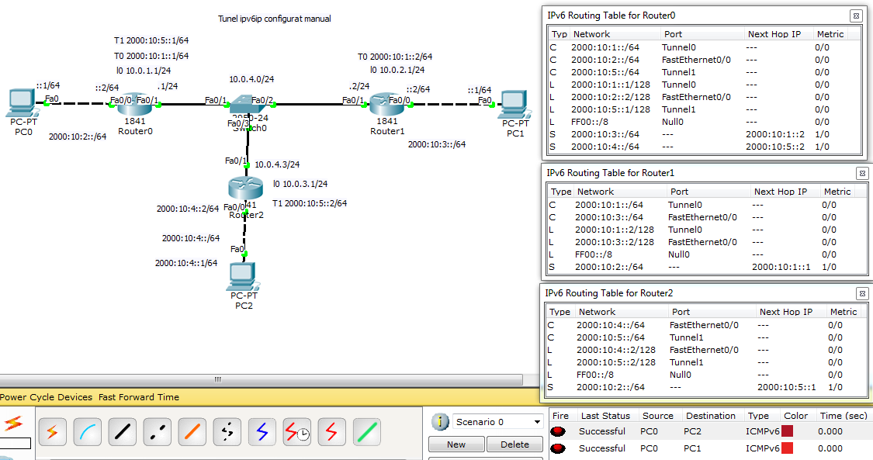

Router0#sh run
interface Loopback0
ip address 10.0.1.1 255.255.255.0
!
interface Tunnel0
no ip address
mtu 1476
ipv6 address 2000:10:1::1/64
ipv6 enable
tunnel source Loopback0
tunnel destination 10.0.2.1
tunnel mode ipv6ip
!
interface Tunnel1
no ip address
mtu 1476
ipv6 address 2000:10:5::1/64
ipv6 enable
tunnel source Loopback0
tunnel destination 10.0.3.1
tunnel mode ipv6ip
!
interface FastEthernet0/0
no ip address
duplex auto
speed auto
ipv6 address 2000:10:2::2/64
ipv6 enable
!
interface FastEthernet0/1
ip address 10.0.4.1 255.255.255.0
duplex auto
speed auto
!
interface Vlan1
no ip address
shutdown
!
ip classless
ip route 10.0.2.0 255.255.255.0 10.0.4.2
ip route 10.0.3.0 255.255.255.0 10.0.4.3
!
ipv6 route 2000:10:3::/64 2000:10:1::2
ipv6 route 2000:10:4::/64 2000:10:5::2
line con 0
!
Router2#sh run

!
interface Loopback0
ip address 10.0.3.1 255.255.255.0
!
interface Tunnel1
no ip address
mtu 1476
ipv6 address 2000:10:5::2/64
ipv6 enable
tunnel source Loopback0
tunnel destination 10.0.1.1
tunnel mode ipv6ip
!
interface FastEthernet0/0
no ip address
duplex auto
speed auto
ipv6 address 2000:10:4::2/64
ipv6 enable
!
interface FastEthernet0/1
ip address 10.0.4.3 255.255.255.0
duplex auto
speed auto
!
interface Vlan1
no ip address
shutdown
!
ip classless
ip route 10.0.1.0 255.255.255.0 10.0.4.1
!
ipv6 route 2000:10:2::/64 2000:10:5:

